Practical 1

Write a C program for each of the following question

1. Display your name and school name in two separate lines

#include <stdio.h>

int main()

{

printf(“My Name is minu \n”);

printf(“My School is southlands College \n”);

return 0;

2. Display the following output using printf() statements

*

**

***

****

*****

#include <stdio.h>

int main(){

printf(“*\n”);

printf(“**\n”);

printf(“***\n”);

printf(“****\n”);

printf(“*****\n”);

return 0;

}

3. Input values from int,float,double and char data types and display the values of each of the variable.

#include<stdio.h>

int main()

{

int a;

float b;

double c;

char d [15];

printf(“Enter an Integer value : ”);

scanf(“%d”,&a);

printf(“Enter a Float value : ”);

scanf(“%f”,&b);

printf(“Enter a Double value : ”);

scanf(“%lf,&c”);

printf(“Enter a Char value : ”);

scanf(“%s”,&d);

printf(“%d %f %lf %s”,a,b,c,d);

return 0;

}

4.Input two integers and display the total

#include<stdio.h>

int main(){

int a,b,tot;

printf("Enter the first number : ");

scanf("%d",&a);

printf("Enter the second number : ");

scanf("%d",&b);

tot=a+b;

printf("Total : %d\n",tot);

return 0;

}

5.Input two numbers with decimals and display the average with decimals

#include<stdio.h>

int main()

{

float no1,no2,avg;

printf("Enter first number : ");

scanf("%f",&no1);

printf("Enter second number : ");

scanf("%f",&no2);

avg=(no1+no2)/2;

printf("Average : %.3f\n",avg);

return 0;

}

6.Input a student name, birth year and display student name with age.

#include<stdio.h>

int main(){

int byear,age;

char name [15];

printf("Enter your name : ");

scanf("%s",&name);

printf("Enter your birth year : ");

scanf("%d",&byear);

age=2018-byear;

printf("Name : %s Age : %d\n",name,age);

return 0;

}

1. Input two numbers, swap the values and display the output. ( Before swap and after swap)

#include <stdio.h>

int main(){

int A,B,temp;

printf("Enter a number for 'A' : ");

scanf("%d",&A);

printf("Enter a number for 'B' : ");

scanf("%d",&B);

temp =A;

A=B;

B=temp;

printf("Now, A = %d\t B = %d\n",A,B);

}

8.Execute the following code and analyze the output.

#include<stdio.h>

main()

{

printf("The color: %s\n", "blue");

printf("First number: %d\n", 12345);

printf("Second number: %04d\n", 25);

printf("Third number: %i\n", 1234);

printf("Float number: %3.2f\n", 3.14159);

printf("Hexadecimal: %x\n", 255);

printf("Octal: %o\n", 255);

printf("Unsigned value: %u\n", 150);

printf("Just print the percentage sign %%\n", 10);

}

Result :

The color: blue

First number: 12345

Second number: 0025

Third number: 1234

Float number: 3.14

Hexadecimal: ff

Octal: 377

Unsigned value: 150

Just print the percentage sign %

Practical 2

Write a C program for each of the following question

**Question 1**

Have the computer print

**HI, HOW OLD ARE YOU?**

in one line. The user then enters his or her age immediately after the question mark. The computer then skips two lines and prints on two consecutive lines.

**WELCOME (age)**

**LET’S BE FRIENDS!**

Write a complete C program to do the above.

#include<stdio.h>

main()

{

int age;

printf("HI, HOW OLD ARE YOU? ");

scanf("%d",&age);

printf("WELCOME %d LETS BE FRIENDS\n",age);

return 0;

}

**Question 2**

Write a program which uses the **format commands** with modifiers to print the following output:

|  |  |  |
| --- | --- | --- |
| **2** | **4** | **8** |
| **3** | **9** | **27** |
| **4** | **16** | **64** |
| **5** | **25** | **125** |

***Remark:***

***Observe how format commands are used in the following program.***

#include <stdio.h>

int main()

{

printf("%5d%5d\n", 1, 2); //Right Align

printf("%5d%5d\n", 10, 20); //Right Align

printf("\n\n\n");

printf("%-5d%-5d\n", 1, 2); //Left Align

printf("%-5d%-5d\n", 10, 20); //Left Align

return 0;

}

#include <stdio.h>

int main()

{

printf("%5d%5d%5d\n",2,4,8);

printf("%5d%5d%5d\n",3,9,27);

printf("%5d%5d%5d\n",4,16,64);

printf("%5d%5d%5d\n",5,25,125);

return 0;

}

**Question 3**

Write a simple program to evaluate the average speed of a car traveled in meters per second (ms-1). Given that

**Distance travelled**

___

**Time taken**

**Average speed=**

Try using integer variables. What would be the problem? Why? How to fix the problem?

#include<stdio.h>

int main(){

float dist,time,avgSpeed;

printf("Enter the distance traveled and the time taken \n");

scanf("%d %d",&dist,&time);

avgSpeed=dist/time;

printf("The average Speed is %.2f meters per second",avgSpeed);

}

**Question 4**

Convert a temperature reading in degrees Fahrenheit to degrees Celsius, using the formula

**C = ( 5 / 9 ) x ( F – 32 )**

Test the program with the following values: 68, 150, 212, 0, -22, -200 (degree Fahrenheit).

#include <stdio.h>

int main()

{

float C,F;

printf("Enter the Fahrenheit value : ");

scanf("%f",&F);

C = ( 5.00 / 9.00 ) * ( F - 32.00 );

printf("Fahrenheit %.2f equals to Celsius %.2f\n",F,C);

return 0;

}

Results :

68 oF = 20 oC 150 oF = 65.56 oC 212 oF = 100 oC

0 oF = -17.78 oC -22 oF = -30 oC -200 oF = -128.89 oC

**Question 5**

What will be output of the following program?

#include<stdio.h>

int main(){

    int i=5,j;

    j=++i+++i+++i;

    printf("%d %d",i,j);

    return 0;

}

Got an error for this ( j=++i+++i+++i;)

But this gives an answer

**j=++i + ++i + ++i;**

* 8 22

But expected answer is 8 21

**Question 6**

What will be output of the following program?

#include<stdio.h>

int main(){

    int i=1;

    i=2+2*i++;

    printf("%d",i);

    return 0;

}

* 4 (OUTPUT)

**Question 7**

What will be output of the following program?

#include<stdio.h>

int main(){

    int a=2,b=7,c=10;

    c=a==b;

    printf("%d",c);

    return 0;

}

* 0 (OUTPUT)

**Question 8**

What will be output of the following program?

#include<stdio.h>

int main(){

    int a=0,b=10;

    if(a=0){

         printf("true");

    }

    else{

         printf("false");

    }

    return 0;

}

* False (OUTPUT)

**Question 9**

What will be output of the following program?

    int a=2,b=7,c=10;

    c=a==b;

    printf("%d",c);

    return 0;

}

* 0 (OUTPUT)

**Question 8**

What will be output of the following program?

#include<stdio.h>

int main(){

    int a=0,b=10;

    if(a=0){

         printf("true");

    }

    else{

         printf("false");

    }

    return 0;

}

* False (OUTPUT)

**Question 9**

What will be output of the following program?

#include<stdio.h>

int main(){

    int a;

    a=015 + 0x71 +5;

    printf("%d",a);

    return 0;

}

* 131 (OUTPUT)

**Question 10**

What will be output of the following program?

#include<stdio.h>

int main(){

     int i=5;

     int a=++i + ++i + ++i;

     printf("%d",a);

     return 0;

}

* 22 (OUTPUT)

But expected answer is 8 2

Practical 3

1. Write a program to input two numbers and display the highest number.

#include<stdio.h>

int main()

{

int no1,no2,max;

printf("Enter two numbers : ");

scanf("%d %d",&no1,&no2);

if (no1>no2)

max=no1;

else

max=no2;

printf("Highest number is %d \n",max);

return 0;

}

1. Write a complete program to ask user enter three integer numbers, and then tell the user the largest value and smallest value among the three numbers.

#include<stdio.h>

int main()

{

int no1,no2,no3,max,min;

printf("Enter Three Numbers ");

scanf("%d %d %d",&no1,&no2,&no3);

if (no1>no2)

{

if (no1>no3)

max=no1;

else

max=no3;

}

else if (no2>no3)

max=no2;

else

max=no3;

printf("Largest value is %d\n",max);

if (no1<no2)

{

if (no1<no3)

min=no1;

else

min=no3;

}

else if (no2<no3)

min=no2;

else

min=no3;

printf("Smallest value is %d\n",min);

return 0;

}

1. Display employee name, new salary, when the user inputs employee name, and basic salary. You can refer following formula and the table to calculate new salary:

New Salary = Basic Salary + Increment

Basic Salary Increment

Less than 5000 5% of Basic Salary

More than or equal 5000

and less than 10000 10% of Basic Salary

More than or equal 10,000 15% of Basic Salary

#include<stdio.h>

int main()

{

char name[25];

float BSal,NSal,increment;

printf("Enter the Employee Name : ");

scanf("%s",&name);

printf("Enter the Basic Salary : ");

scanf("%f",&BSal);

if (BSal<5000)

increment=BSal*5/100;

else if (BSal<10000)

increment=BSal*10/100;

else

increment=BSal*15/100;

NSal=BSal+increment;

printf("%s your New Salary is %.2f\n",name,NSal);

return 0;

}

1. Diameter, Circumference and Area of a Circle) Write a program that reads in the radius of a circle and prints the circle’s diameter, circumference and area. Use the constant value 3.14159 for π. Perform each of these calculations inside the printf statement(s) and use the conversion specifier %f.

#include<stdio.h>

int main()

{

float rad;

printf("Enter the Radius of the circle : ");

scanf("%f",&rad);

printf("Diameter is %.2f \n",rad*2.0);

printf("Circumference is %.2f \n",rad*2.0*3.14159);

printf("Area is %.2f \n",rad*rad*3.14159);

return 0;

}

1. Write a program that reads in two integers and determines and prints if the first is a multiple of the second.

#include<stdio.h>

int main()

{

int no1,no2;

printf("Enter two integers : ");

scanf("%d %d",&no1,&no2);

if (no1%no2==0)

printf("%d is a multiple of %d\n",no1,no2);

else

printf("%d is not a multiple of %d\n",no1,no2);

return 0;

}

1. Write a C program that prints the integer equivalents of some uppercase letters, lowercase letters, digits and special symbols. As a minimum, determine the integer equivalents of the following: A B C a b c 0 1 2 $ * + / and the blank character.

#include<stdio.h>

int main()

{

printf("A = %d\n", 'A');

printf("B = %d\n", 'B');

printf("C = %d\n", 'C');

printf("a = %d\n", 'a');

printf("b = %d\n", 'b');

printf("c = %d\n", 'c');

printf("0 = %d\n", '0');

printf("1 = %d\n", '1');

printf("2 = %d\n", '2');

printf("$ = %d\n", '$');

printf("* = %d\n", '*');

printf("+ = %d\n", '+');

printf("/ = %d\n", '/');

printf("Blank character = %d\n", ' ');

return 0;

}

1. The gross remuneration of a company salesman comprises the Basic Salary and certain additional allowances and bonuses as given below:

Salesmen with over 5 years’ service receive a 10% additional allowance of Basic Salary each month.

Salesmen working in Colombo ( Input character ‘C’ if the city is Colombo) receive an additional allowance of Rs. 2,500/- per month.

The monthly bonus payment is computed as given below:

|  |  |
| --- | --- |
| **Monthly Sales(Rs)** | **Bonus as a percentage**  **of monthly sales** |
| 0-25000  25000-50000  >=50000 | 10  12  15 |

Write a program to output the gross monthly remuneration of a salesman.

#include <stdio.h>

int main()

{

float basic_sal,gross_sal,sales;

int service_yrs;

char city;

printf("Enter the basic salary : ");

scanf("%f",&basic_sal);

printf("Enter the years of the service : ");

scanf("%d",&service_yrs);

printf("Enter 'C' if the working city is Colombo. If not Enter Any other letter : ");

scanf("%s",&city);

printf("Monthly sales : ");

scanf("%f",&sales);

if (service_yrs>5)

gross_sal = basic_sal + basic_sal*10/100;

else

gross_sal = basic_sal;

switch(city)

{

case 'c' :

gross_sal = gross_sal + 2500;break;

case 'C' :

gross_sal = gross_sal + 2500;break;

default :

gross_sal = gross_sal;

}

if (sales<25000)

gross_sal = gross_sal + sales*10/100;

else if (sales<50000)

gross_sal = gross_sal + sales*12/100;

else

gross_sal = gross_sal + sales*15/100;

printf("Gross salary = %.2f \n",gross_sal);

return 0;

Practical 4

**Part A**

1. Input 10 numbers and to output number of positive, number of negative, number of zeros.

#include<stdio.h>

int main()

{

int no,i,p=0,n=0,z=0;

for(i=0;i<10;i++)

{

printf("Enter %d number :",i+1);

scanf("%d",&no);

if(no>0)

p=p+1;

else if(no<0)

n=n+1;

else

z=z+1;

}

printf("\nNo of positives :%d\n",p);

printf("No of negatives : %d\n",n);

printf("No of zeros : %d\n",z);

return 0;

}

1. Input Marks of 10 students and output the maximum , minimum and average Marks.

#include<stdio.h>

int main()

{

int marks,i=0,max,min,sum=0;

float avg;

for(i=0;i<10;i++)

{

printf("Enter marks of student %d : ",i+1);

scanf("%d",&marks);

sum=sum+marks;

if(marks>max)

max=marks;

if(marks<min)

min=marks;

}

avg=(float)sum/10;

printf("\nThe maximum marks :%d\n",max);

printf("The minimum marks :%d\n",min);

printf("The average marks :%.2f\n",avg);

return 0;

}

1. Input price of 10 items and display the average value of an Item , number of items which the price is greater than 200.

#include<stdio.h>

int main()

{

int i,counter=0;

float price,sum=0,avg;

for(i=0;i<10;i++)

{

printf("Enter price of %d item : ",i+1);

scanf("%f",&price);

sum=sum+price;

if(price>200)

counter++;

}

avg=sum/10;

printf("\nThe average value of an item : %.2f\n",avg);

printf("Number of items which the price is greater than 200 : %d\n",counter);

return 0;

}

1. Input the Employee no and the Basic Salary of the Employees in an organisation ending with the dummy value -999 for Employee no and count the number Employees whose Basic Salary >=5000.

#include<stdio.h>

int main()

{

int EmpNo,counter=0;

float BSal;

while(EmpNo!=-999)

{

printf("Enter the employee number : ");

scanf("%d",&EmpNo);

printf("Enter the basic salery : ");

scanf("%d",&BSal);

if(BSal>=5000)

counter++;

}

printf("Number of employees whose basic salery gretaer than 5000 : %d\n",counter);

return 0;

}

1. Input employee number, and hours worked by employees, and to display the following:

Employee number, Over Time Payment, and the percentage of employees whose Over Time Payment exceeding the Rs. 4000/-.

The user should input –999 as employee number to end the program, and the normal Over Time Rate is Rs.150 per hour and Rs. 200 per hour for hours in excess of 40.

#include<stdio.h>

int main()

{

int EmpNo,counter=0,hours,rate,ot=0;

while(EmpNo!=-999)

{

printf("Enter the employee number : ");

scanf("%d",&EmpNo);

printf("Enter the hours worked : ");

scanf("%d",&hours);

if(hours>=40)

rate=200;

else

rate=150;

ot=hours*rate;

if(ot>=4000)

counter++;

}

printf("number of employees whose Over Time Payment is gretaer than 4000 : %d",counter);

return 0;

}

**Part B**

**Switch Statements**

Q1) Use If-Else and write a program that reads an integer and determines and prints if the number is even or odd. (I.e. divisible by 2)

#include<stdio.h>

int main()

{

int no;

printf("Input a number : ");

scanf("%d",&no);

if(no%2==0)

printf("It is an Even number\n");

else

printf("It is an Odd number\n");

return 0;

}

Re-write the above program using a switch statement instead of an If-Else statement!

#include<stdio.h>

int main ()

{

int number;

printf("Enter a number : ");

scanf("%d",&number);

switch(number%2)

{

case 0:

printf("%d is an even number\n",number);

break;

case 1:

printf("%d is an odd number\n",number);

}

return 0;

}

Q2) Write a simple menu driven calculator to perform (+ - / *) operations. (The program must display a menu to select the desired operator.)

# include <stdio.h>

int main()

{

float no1,no2,ans;

int operNum;

char oper;

printf("\t CALCULATOR \n");

printf("Instructions: \n");

printf("1 : + \n");

printf("2 : - \n");

printf("3 : * \n");

printf("4 : / \n");

printf("Enter the First Number : ");

scanf("%f",&no1);

printf("Enter the Second Number : ");

scanf("%f",&no2);

printf("Enter the Operator Number : ");

scanf("%d",&operNum);

switch(operNum)

{

case 1:

ans=no1+no2;

oper='+';

break;

case 2:

ans=no1-no2;

oper='-';

break;

case 3:

ans=no1*no2;

oper='*';

break;

case 4:

ans=no1/no2;

oper='/';

break;

default:

printf("Wrong Operator Number please Retry");

oper='X';

break;

}

if(oper!='X')

printf("The Answer for %.2f %c %.2f is %.2f\n",no1,oper,no2,ans);

return 0;

}

Q3) Create a text-based, menu-driven program that allows the user to choose whether to calculate the circumference of a circle, the area of a circle or the volume of a sphere. The program should then input a radius from the user, perform the appropriate calculation and display the result.

# include <stdio.h>

int main()

{

int choice;

float r,circum,area,volume,pi=3.14;

printf("1.Circumference of a circle \n");

printf("2.Area of a circle\n");

printf("3.Volume of a sphere\n");

printf("\nWhat is your choice? ");

scanf("%d",&choice);

switch(choice)

{

case 1: printf("Enter the radius : ");

scanf("%f",&r);

circum=2.00*pi*r;

printf("\nThe circumference is %.2f\n",circum);break;

case 2: printf("Enter the radius : ");

scanf("%f",&r);

area=pi*r*r;

printf("\nThe are of the circle is : %.2f\n",area);break;

case 3: printf("Enter the radius : ");

scanf("%f",&r);

volume=(4.00/3.00)*pi*r*r*r;

printf("\nThe volume of sphere is : %.2f\n",volume);break;

default : printf("Invalid choice\n");

}

return 0;

}

Q5) Write a C program to read a character from the user and determine whether the given letter is vowel or not. (Use a switch statement which also includes ‘default’ state).

#include <stdio.h>

int main()

{

char l;

printf("Enter a Letter : ");

scanf("%c",&l);

switch (l)

{

case 'a' : printf("It is a vowel\n");break;

case 'e' : printf("It is a vowel\n");break;

case 'i' : printf("It is a vowel\n");break;

case 'o' : printf("It is a vowel\n");break;

case 'u' : printf("It is a vowel\n");break;

case 'A' : printf("It is a vowel\n");break;

case 'E' : printf("It is a vowel\n");break;

case 'I' : printf("It is a vowel\n");break;

case 'O' : printf("It is a vowel\n");break;

case 'U' : printf("It is a vowel\n");break;

default : printf("It is not a vowel\n");

}

return 0;

}

Q6) Write a C program to enter month number and print total number of days in month using switch case. First assume that the given month belongs to a non-leap year.

#include <stdio.h>

int main()

{

int m;

printf("Enter the month number : ");

scanf("%d",&m);

switch (m)

{

case 1 : printf("31 days\n");break;

case 2 : printf("28 days\n");break;

case 3 : printf("31 days\n");break;

case 4 : printf("30 days\n");break;

case 5 : printf("31 days\n");break;

case 6 : printf("30 days\n");break;

case 7 : printf("31 days\n");break;

case 8 : printf("31 days\n");break;

case 9 : printf("30 days\n");break;

case 10 : printf("31 days\n");break;

case 11 : printf("30 days\n");break;

case 12 : printf("31 days\n");break;

default : printf("Invalid month\n");

}

return 0;

}

**Loops (While, Do..While, For)**

Q1) Write a C program to print numbers from 0 to 100. (You are required to write 3 separate answers each using While, Do..While, For, looping structures).

Using While loop :

#include <stdio.h>

int main()

{

int no=0;

while (no<=100)

{

printf("%d ",no);

no++;

}

return 0;

}

Using Do while loop :

#include <stdio.h>

int main()

{

int no=1;

do

{

printf("%d ",no);

no++;

}while (no<=100);

return 0;

}

Using For loop :

#include <stdio.h>

int main()

{

int no;

for(no=1;no<=100;no++)

printf("%d ",no);

return 0;

}

Q2) Write a C program to calculate and print the total of 10 marks and the average. If the average is less than 50 program should print “Fail!” otherwise “Pass!”

#include <stdio.h>

#include <stdlib.h>

int main()

{

int marks,total=0,counter;

float avg;

for(counter=1;counter<=10;counter++)

{

printf("Enter the marks for subject %d : ",counter);

scanf("%d",&marks);

total=total+marks;

}

avg=(float)total/10;

printf("Total of Marks : %d\n",total);

printf("Average of Marks : %.2f ",avg);

if(avg<50)

printf("Fail\n");

else

printf("Pass\n");

return 0;

}

Q3) Write a C program to calculate factorial of a user given number.

Hint:

Select an appropriate looping structure.

Factorial of ‘0’ is ‘1’ (0! = 1)

Ex: factorial of number 5 is calculated as 5! = 5*4*3*2*1

#include <stdio.h>

int main()

{

int i,f=1,no;

printf("Enter a number for find factorial : ");

scanf("%d",&no);

for(i=1;i<=no;i++)

f=f*i;

printf("Factorial of %d is : %d",no,f);

return 0;

}

Q4) Write a C program to calculate the sum of all digits of a user given number.

If user input 123 your program should output 6. (calculated as 1+2+3)

#include <stdio.h>

int main()

{

int no,temp,digit,sum=0;

printf("Enter a value : ");

scanf("%d",&no);

temp=no;

while(no>0)

{

digit=no%10;

sum=sum+digit;

no /=10;

}

printf("Given number = %d \n",temp);

printf("Sum of digits %d = %d \n",temp,sum);

return 0;

}

Q5) Write a C program to reverse the digits of a number using *do*-*while* statem

# include <stdio.h>

int main()

{

int no,digit=0,rev=0;

printf("Enter a number : ");

scanf("%d",&no);

do

{

digit=no%10;

rev=rev*10+digit;

no=no/10;

}while(no>0);

printf("The reverse is : %d\n",rev);

return 0;

}

Q6) Write a C program to calculate nth power of a given integer. The user input base and exponent. (Do NOT use inbuilt functions, instead use a loop)

# include <stdio.h>

int main()

{

int base,exponent,Result=1;

printf("Enter the base : ");

scanf("%d",&base);

printf("Enter the exponent : ");

scanf("%d",&exponent);

while(exponent!=0)

{

Result=Result*base;

exponent--;

}

printf("The answer is %d\n",Result);

return 0;

}

Q7) Write a C program to print first 10 numbers of “Fibonacci Sequence”.

#include <stdio.h>

int main()

{

int i,n,t1 = 0, t2 = 1, NextTerm;

printf("Enter the number of terms: ");

scanf("%d",&n);

printf("Fibonacci Series: ");

for (i=1;i<=n;++i)

{

printf("%d, ", t1);

NextTerm = t1 + t2;

t1 = t2;

t2 = NextTerm;

}

return 0;

}

Q8) Write a C program to check whether a given number is an Armstrong Number! (Refer to previous flowcharts)

#include <stdio.h>

int main(){

int number,sum = 0, rem = 0, cube = 0, temp;

printf ("Enter a number ");

scanf("%d", &number);

temp = number;

while (number != 0)

{

rem = number % 10;

cube = pow(rem, 3);

sum = sum + cube;

number = number / 10;

}

if (sum == temp)

printf ("The given number is an armstrong number\n");

else

printf ("The given number is not a armstrong number\n");

return 0;

}

Q9) Write a C program to print all the ASCII values for letters A to Z.

#include <stdio.h>

int main()

{

char c;

for(c = 'A'; c <= 'Z'; c++)

printf("%c ASCII value = %d \n", c, c);

return 0;

}

Q10) Write a program to print this pattern.

*

**

***

****

*****

#include <stdio.h>

int main()

{

int a,b;

for(a = 1; a <= 5; a++)

{

for(b = 1; b <= a; b++)

{

printf("*");

}

printf("\n");

}

return 0;

}

Q11) Write a program to check whether a given number is prime or not.

#include <stdio.h>

int main()

{

int no;

printf("Enter a number : ");

scanf("%d\n",&no);

if (no%no==1)

printf("It's prime number");

else

printf("It isn't a prime number");

return 0;

}

Q12.1) Write a C program to print all factors of a given integer.

#include <stdio.h>

int main()

{

int no,x,fact;

printf("Enter a number : ");

scanf("%d",&no);

printf("\n");

for(x=1;x<=no;x++)

{

fact=no%x;

if(fact==0)

printf("%d ",x);

}

printf("\n");

return 0;

}

Q12.2) Write a C program to add all user inputs until user input ‘-1’. And then display the sum.

#include <stdio.h>

int main()

{

int no,sum=0,x=1;

while(no!=(-1))

{

printf("Enter number %d : ",x++);

scanf("%d",&no);

sum=sum+no;

}

printf("\nThe sum is : %d ",sum);

return 0;

}

Q13) Write a C program to read user inputs for an integer array (size = 10) and print the array.

#include <stdio.h>

int main()

{

int XY[10];

int i;

for(i=0;i<10;i++)

{

printf("Enter number %d : ",i+1);

scanf("%d",&XY[i]);

}

for(i=0;i<10;i++)

printf("%d\t",XY[i]);

return 0;

}

Q14) Re-Write the above code to count all the even numbers in above integer array and display the count.

#include <stdio.h>

int main()

{

int XY[10];

int i,counter=0;

for(i=0;i<10;i++)

{

printf("Enter number %d : ",i+1);

scanf("%d",&XY[i]);

if(XY[i]%2==0)

counter=counter+1;

}

printf("\n");

for(i=0;i<10;i++)

printf("%d\t",XY[i]);

printf("\n\nNumber of even numbers : %d \n\n",counter);

return 0;

}

Practical 5 & Practical 6

1. Declare a Single dimensional array with 10 elements. Input the values to the array and find the followings;
2. Minimum value
3. Maximum value
4. Average value
5. Reverse order of values

#include <stdio.h>

int main()

{

int arr[10];

int i, max, min,tot=0;

float avg;

for(i=0; i<10; i++)

{

printf("Enter %d element to the array: ",i);

scanf("%d", &arr[i]);

tot=tot+arr[i];

}

max = arr[0];

min = arr[0];

for(i=1; i<10; i++)

{

if(arr[i] > max)

max = arr[i];

if(arr[i] < min)

min = arr[i];

}

avg=(float)tot/10;

printf("The minimum value is %d \nThe maximum value is %d",min,max);

printf("\nThe average is %.2f\n",avg);

for(i=9;i>=0;i--)

printf("%d\t",arr[i]);

return 0;

}

1. Declare two single dimensional array with the size given by the user and find , display the followings;

* Scalar Sum ( Adding values of each element of an array)

#include <stdio.h>

int main()

{

int arr[10];

int sum=0;

int i;

for (i=0;i<10;i++)

{

printf("Input the %d value to array =",i+1);

scanf("%d",&arr[i]);

sum=arr[i]+sum;

}

printf("\nSum is = %d\n",sum);

return 0;

}

* Vector Sum (Adding values of each relative elements of an array and store them in third array)

#include <stdio.h>

int main()

{

int arr1[5],arr2[5];

int i,sum[5];

for (i=0;i<5;i++)

{

printf("input values to array 1 =");

scanf("%d",&arr1[i]);

printf("input values to array 2 =");

scanf("%d",&arr2[i]);

sum[i]=arr1[i]+arr2[i];

}

for (i=0;i<5;i++)

printf("\n%d + %d = %d\n",arr1[i],arr2[i],sum[i]);

return 0;

}

* Vector Product (Multiply values of each relative elements of an array an store them in 3rd arr)

#include <stdio.h>

int main()

{

int arr1[5],arr2[5],i,product[5];

for (i=0;i<5;i++)

{

printf("input values to array 1 =");

scanf("%d",&arr1[i]);

printf("input values to array 2 =");

scanf("%d",&arr2[i]);

product[i]=arr1[i]*arr2[i];

}

for (i=0;i<5;i++)

printf("%4d",product[i]);

return 0;

}

* Scalar Product (Multiply values of each relative elements of an array and store them in third array. After placing the values in third array add and display the sum of all the elements)

#include <stdio.h>

int main()

{

int arr1[5],arr2[5];

int i,product[5],tot=0;

for (i=0;i<5;i++)

{

printf("input values to array 1 =");

scanf("%d",&arr1[i]);

printf("input values to array 2 =");

scanf("%d",&arr2[i]);

product[i]=arr1[i]*arr2[i];

}

for (i=0;i<5;i++)

{

printf("\n%4d",product[i]);

tot=tot+product[i];

}

printf("\n\nThe total is %d\n",tot);

return 0;

}

Tutorial 01

Briefly explain the need of programming language?

* Languages like English, Chinese etc. science computer can understate only 1 s and 0s. Human can understated English. So, programming language is like language translator to communicate between human and computer. A hence it converts binary’s to English language.

1. Compare the differences between following.
2. source code vs machine code

source code is text written in a computer programming language code written by programmer.

Machine code in system of instructions and data executed to the CPU. usually compiler and interpreters convert the source code into machine code. Because machine can only understand 1s and 0s.

1. high level language vs low level language

Low-level languages those languages which are extremely close to machine language. They are also known as Assembly languages. Machine code is known as low level because unlike high level programming languages it doesn't need anything else like compilers or something.

1. compiler vs interpreter

In contrast with a compiler, an interpreter is a program which imitates the execution of programs written in a source language. Another difference between Compiler and interpreter is that Compiler converts the whole program in one go on the other hand Interpreter converts the program by taking a single line at a time.

1. syntax errors vs logical errors

Syntax errors occur when a program does not conform to the grammar of a programming language, and the compiler cannot compile the source file.

Logic errors occur when a program does not do what the programmer expects it to do.

1. Who developed C language.

Dennis Ritchie

1. How to write comments in C language.

A comment starts with a slash asterisk /* and ends with a asterisk slash */ and can be anywhere in your program.

Snigale line //…………………….//

Multiline /*……………………

……………………*/

1. Which is the function that is essential in a C program?

int main()

Tutorial 02

1. How do you write comments in a c program? What is the purpose of comments in a program?

A comment [start with a slash asterisk /*and ends with asterisk slash */ and can be anywhere in your programme.

* Single line //…………….//
* Multiline /*………….

………………….

,,,,,,,,,,,,,,,,,,,,,,*/

2. Which is the function that is essential in a C program?

* int main()

3. What is the purpose of ‘scanf’ ?

* scanf inputs something from the standard input stream. (it allows the user to input data)

4. Is ‘standard c’ a case sensitive language?

* Yes , c is case sensitive Language.

5. Determine which of the following are valid identifiers. If invalid, explain why.

(a) record1 (e) $tax (h) name-and-address

(b) 1record (f) name (i) name_and_address

(c) file-3 (g) name and address (j) 123 - 45 - 6789

(d) return

* recode1: -Valid
* 1recode: -Invalid (First charter should be alphabet or underscore)
* return: -Invalid (Can’t use reserved words)
* $tax: -invalid (No Special symbol other than underscore)
* name:- Valid
* name and address:- blanks are not allowed
* name-and-address:-no special symbol other than underscore
* name_and_address:-Valid
* 123 - 45 - 6789;-(first character should be alphabet or underscore and no special symbol other than underscore)
* file-3 :-(no special symbol other than underscore)

6. State whether each of the following is true or false. If false, explain why.

a) Function printf always begins printing at the beginning of a new line.

False (if we want a new line, we have to use line break)

b) Comments cause the computer to print the text enclosed between /* and */ on the screen when the program is executed.

False ( comments are ignored by he compiler)

c) The escape sequence \n when used in a printf format control string causes the cursor to position to the beginning of the next line on the screen.

True

d) All variables must be defined before they’re used.

True

e) All variables must be given a type when they’re defined.

True

f) C considers the variables, number and NuMbEr to be identical.

False(c is case sensitive Language)

g) A program that prints three lines of output must contain three printf statements.

False(we can print 3lines by using 1 prientf statements)

7. What does the following code print?

printf( "*\n**\n***\n****\n*****\n" );

*

**

***

****

*****

8. Identify and correct the errors in each of the following statements. (Note: There may be more than one error per statement.)

a) scanf( "d", value );

scanf( "d", **&**value );

b) printf( "The product of %d and %d is %d"\n, x, y );

printf( "The product of %d and %d is %d**"\n”,** x, y**,(x+y)** );

c) Scanf( "%d", anInteger );

Scanf( "%d", **&**anInteger );

d) printf( "Remainder of %d divided by %d is\n", x, y, x % y );

printf( "Remainder of %d divided by %d is **%d**\n", x, y, x % y );

e) print( "The sum is %d\n," x + y );

print**f**( "The sum is %d\n," x + y );

f) Printf( "The value you entered is: %d\**n”,** &value );

9. What, if anything, prints when each of the following statements is performed? If nothing prints, then answer “Nothing.” Assume x = 2 and y = 3 .

a) printf( "%d", x ); 2

b) printf( "%d", x + x );

4

c) printf( "x=" );

x=

d) printf( "x=%d", x );

x=2

e) printf( "%d = %d", x + y, y + x );

5=5

f) z = x + y;

nothing

g) scanf( "%d%d", &x, &y );

nothing

h) /* printf( "x + y = %d", x + y ); */

nothing

i) printf( "\n" );

nothing

10. State which of the following are true and which are false. If false, explain your answer.

a) C operators are evaluated from left to right.

False (They are evaluated according to their precedence and associativity)

b) The following are all valid variable names: _under_bar_ , m928134 , t5 , j7 , her_sales , his_account_total , a , b , c , z , z2 .

True

c) The statement printf("a = 5;"); is a typical example of an assignment statement.

False (This statements will just print a=5;to screen)

d) A valid arithmetic expression containing no parentheses is evaluated from left to right.

False(It will be evacuated according to their precedence and associativity)

e) The following are all invalid variable names: 3g , 87 , 67h2 , h22 , 2h

False(h22 is a valid variable)

Tutorial 03

Q1. Write four different C statements that each add 1 to integer variable x.

* x++
* ++x
* x+=1
* x=x+1

Q2. Write a single C statement to accomplish each of the following:

1. Assign the sum of x and y to z and increment the value of x by 1 after the calculation.

* z=(x ++) + y

1. Multiply the variable product by 2 using the *= operator.

* Product=*2

1. Multiply the variable product by 2 using the = and * operators.

* Product=Product*2

1. Test if the value of the variable count is greater than 10. If it is, print “Count is greater than 10.”

* If(count>10) printf(“count is greater than 10”);

1. Decrement the variable x by 1, then subtract it from the variable total.

* Total-=(--x);

1. Add the variable x to the variable total, then decrement x by 1.

* Total=Total+(x--);

1. Calculate the remainder after q is divided by divisor and assign the result to q. Write this statement two different ways.

* q=q%divisor;
* q%=divisor;

1. Print the value 123.4567 with 2 digits of precision. What value is printed?

* printf(“%.2f,123,4567);

i) Print the floating-point value 3.14159 with three digits to the right of the decimal point. What value is printed?

* printf(“%f, 3.14159);

Q3. Write single C statements that

1. Input integer variable x with scanf.

* scanf(“ %d”.&x);

1. Input integer variable y with scanf.

* scanf(“ %d”,&y);

1. Initialize integer variable i to 1.

* i=1;

1. Initialize integer variable power to 1.

* power=1;

1. Multiply variable power by x and assign the result to power.

* power=power*x;

1. Increment variable i by 1.

* i=i+1
* i+=1
* i++
* ++i

1. Test i to see if it’s less than or equal to y in the condition of a while statement.

* while(i<=y);

1. Output integer variable power with printf.

* printf(“%d”,power);

Tutorial 05

**Writing switch condition, while, do while & for loops**

**Switch**

Input two numbers and display the outputs of the basic mathematic operations. The output screen should be displayed as follows;

Enter two numbers ____ ____

1. +
2. –
3. *
4. /

Please enter your Choice ___

#include <stdio.h>

#include <stdlib.h>

int main()

{int choise;

float x,y;

printf("Enter your two numbers \n");

scanf("%f %f",&x,&y);

printf("\n1+\n2.-\n3.*\n4./\n");

printf("Enter your choice ");

scanf("%d",&choise);

switch(choise)

{

case 1:printf("Answer =%.2f",x+y);break;

case 2:printf("Answer =%.2f",x-y);break;

case 3:printf("Answer =%.2f",x*y);break;

case 4:printf("Answer =%.2f",x/y);break;

} return 0;

}

**While loop**

1. Input 10 numbers and display the total count of odd & even numbers in the entered number series.

#include <stdio.h>

#include <stdlib.h>

int main()

{ intx,even=0,odd=0,count=1;

while (count<=10)

{

printf("Enter Your Number %d:",count);

scanf("%d",&x);

if(x%2==0)

even++;

else

odd++;

count++;

}

printf("Number of Even numbers:%d\n",even);

printf("Number of Odd Numbers:%d\n",odd);

return 0;

}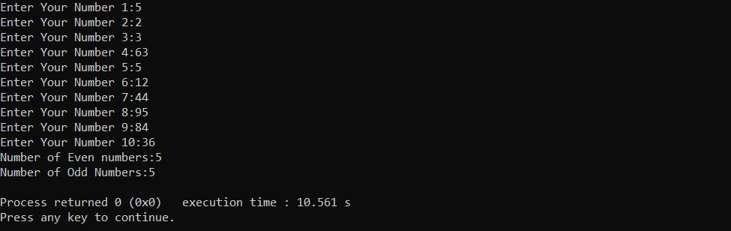

1. Modify the above program in to enter series of numbers terminates when the user enter -99 and display the same expected output.

#include <stdio.h>

#include <stdlib.h>

int main()

{ intx,even=0,odd=0;

printf("Enter Your Number :");

scanf("%d",&x);

while (x!=-99)

{ if(x%2==0)

even++;

else

odd++;

printf("Enter Your Number :");

scanf("%d",&x);

}

printf("Number of Even numbers:%d\n",even);

printf("Number of Odd Numbers:%d\n",odd);

return 0;

}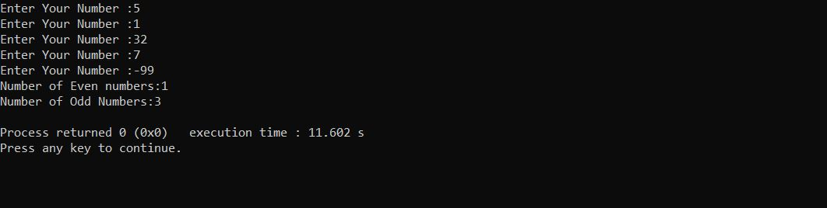

**Do while loop**

Rewrite the programs for the above while loop question 1 & 2 using do while loop

#include <stdio.h>

#include <stdlib.h>

int main()

{ intx,even=0,odd=0;

printf("Enter Your Number :");

scanf("%d",&x);

do

{ if(x%2==0)

even++;

else

odd++;

printf("Enter Your Number :");

scanf("%d",&x);

}while(x!=-99);

printf("Number of Even numbers:%d\n",even);

printf("Number of Odd Numbers:%d\n",odd);

return 0;

}

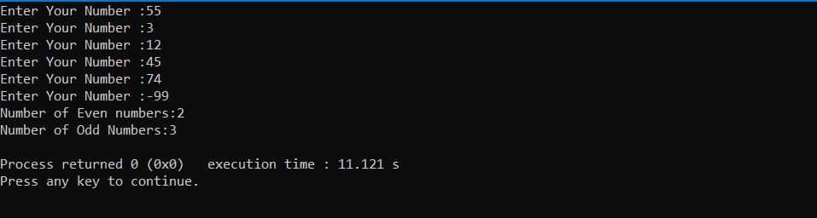

**For loop**

1. Input 10 numbers and display the average value using the for loop

#include <stdio.h>

#include <stdlib.h>

int main()

{

int sum=0,num,counter;

float avg;

for(counter=1;counter<=10;counter++)

{

printf("Enter your %d Number : ",counter);

scanf("%d",&num);

sum=num+sum;

}

avg=(float)sum/10;

printf("Average value is:%.2f \nTotal is:%d",avg,sum);

return 0;

}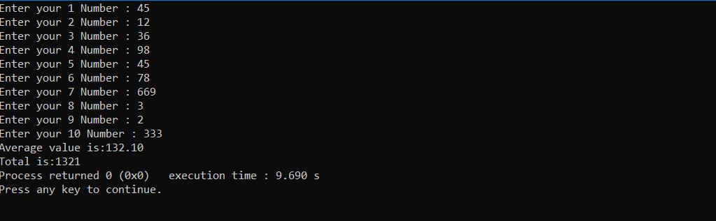

1. Display the following output using the for loop

*

**

***

****

*****

#include <stdio.h>

#include <stdlib.h>

int main()

{ inti,j;

for(i=1;i<6;i++)

{

for(j=0;j<i;j++)

{

printf("*");

}

printf("\n");

}

return 0;

}

**Tutorial 06 –Working with Multi-Dimensional Arrays (Matrix)**

**Write a C program for the followings;**

Declare two 3 x 3 square matrices and display the matrix sum.

Following illustration shows the process of calculating the matrix sum. The values are used as samples.

|  |  |  |  |  |  |  |  |  |  |  |
| --- | --- | --- | --- | --- | --- | --- | --- | --- | --- | --- |
| 3 | 2 | 4 | + | 2 | 6 | 3 | = | 5 | 8 | 7 |
| 1 | 4 | 6 | 4 | 3 | 2 | 5 | 7 | 8 |
| 4 | 3 | 2 | 5 | 1 | 7 | 9 | 4 | 9 |

#include <stdio.h>

#include <stdlib.h>

int main()

{ int i,j,arr1[3][3],arr2[3][3],arr3[3][3];

printf("Array 1\n");

for(i=0;i<3;i++)

{

for(j=0;j<3;j++)

{

printf("Enter the %d*%d Element:",i+1,j+1);

scanf("%d",&arr1[i][j]);

}

}

printf("Array 2\n");

for(i=0;i<3;i++)

{

for(j=0;j<3;j++)

{

printf("Enter the %d*%d Element:",i+1,j+1);

scanf("%d",&arr2[i][j]);

}

}

printf("Answer Matrix\n");

for(i=0;i<3;i++)

{

for(j=0;j<3;j++)

{

arr3[i][j]=arr1[i][j]+arr2[i][j];

printf("%5d",arr3[i][j]);

}

printf("\n");

}

return 0;

}

Tutorial 07

**Functions in C Language**

1. Write a function that will read 2 numbers and calculate and display sum and differences.

#include <stdio.h>

#include <stdlib.h>

void sumidf()

{ int total,n1,n2;

printf("Enter Two Numbers:");

scanf("%d %d",&n1,&n2);

printf("Summation %d \nDifference %d",n1+n2,n1-n2);

}

int main()

{

sumidf();

return 0;

}

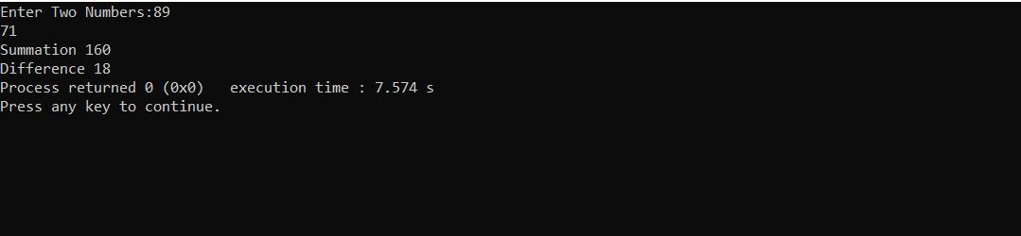

1. Write a function that accepts 2 numbers as parameters and calculate and display sum and difference.

#include <stdio.h>

#include <stdlib.h>

void sumidf(int n1,int n2)

{ int total;

printf("Summation %d\n",n1+n2);

printf("Difference %d\n",n1-n2);

}

int main()

{

int x,y;

printf("Enter your two numbers:");

scanf("%d %d",&x,&y);

sumidf(x,y);

return 0;

}

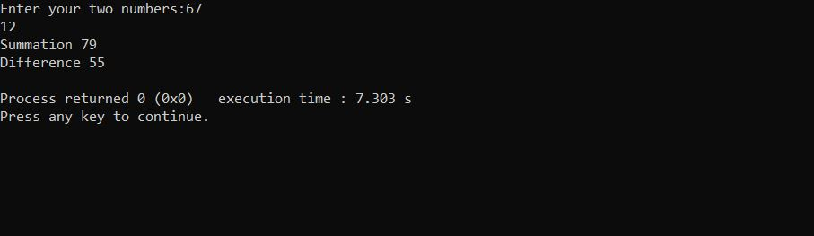

1. Write a function that accepts 2 whole numbers as parameters and calculate and return the product.

#include <stdio.h>

#include <stdlib.h>

int product(int n1,int n2)

{

int pro;

pro=n1*n2;

return pro;

}

int main()

{

int x,y;

printf("Enter your two numbers:");

scanf("%d %d",&x,&y);

printf("The product %d",product(x,y));

return 0;

}

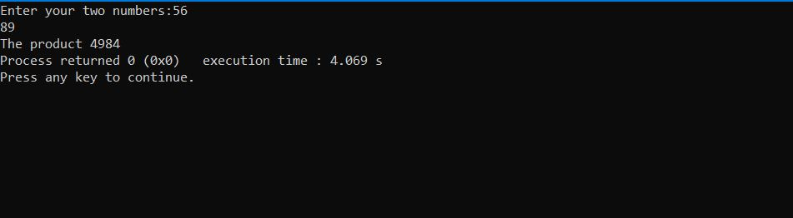

1. Write a function that accepts 2 whole numbers as parameters and calculate and return the quotient.

#include <stdio.h>

#include <stdlib.h>

int quotient(int n1,int n2)

{

int quo;

quo=n1/n2;

return quo;

}

int main()

{

int x,y;

printf("Enter your two numbers:");

scanf("%d %d",&x,&y);

printf("The Quotient %d",quotient(x,y));

return 0;

}

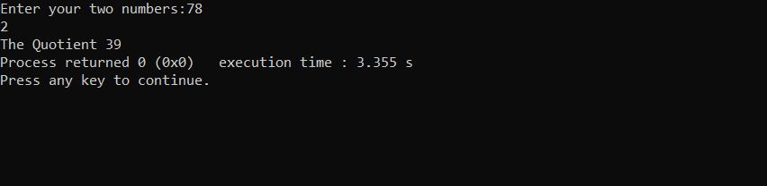

1. Write a function to read 2 numbers and display the sum. Call this function from the main function several times.

#include <stdio.h>

#include <stdlib.h>

void sumidf()

{ int total,n1,n2;

printf("Enter Two Numbers:");

scanf("%d %d",&n1,&n2);

printf("Summation %d \nDifference %d\n",n1+n2,n1-n2);

}

int main()

{

int i;

for(i=1;i<=3;i++)

sumidf();

return 0;

} 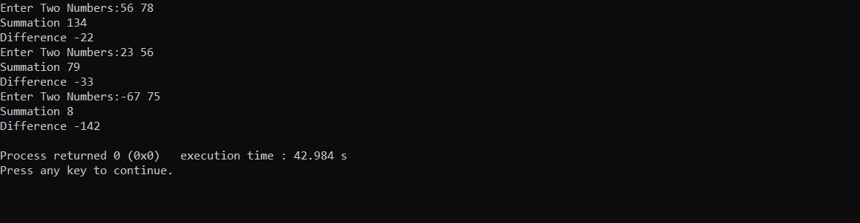

1. Write a function which accepts 2 integers as parameters and display the sum, difference and product using a single printf statement.

#include <stdio.h>

#include <stdlib.h>

void sumdifpro(int n1, int n2 )

{

printf("\nSummation=%d \nDifference=%d\nProduct=%d",n1+n2,n1-n2,n1*n2);

}

int main()

{

int x,y;

printf("Enter Two Numbers:");

scanf("%d %d",&x,&y);

sumdifpro(x,y);

return 0;

}

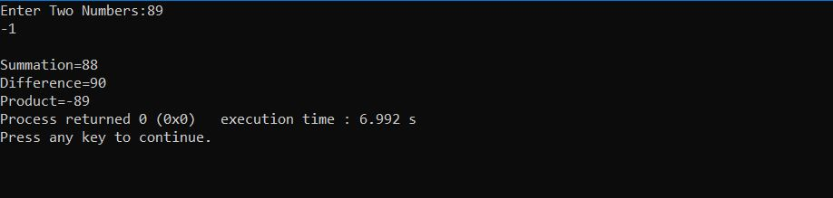

1. Write a function which accepts an integer and a float value as parameters and return the product as a double value. Display the result from the main function.

#include <stdio.h>

#include <stdlib.h>

double product(int n1,float n2)

{

double pro;

pro=n1*n2;

return pro;

}

int main()

{

int x;

float y;

printf("Enter Two Numbers:");

scanf("%d %f",&x,&y);

printf("\n\tProduct of %d and %.2f =%.2f\n",x,y,product(x,y));

return 0;

}

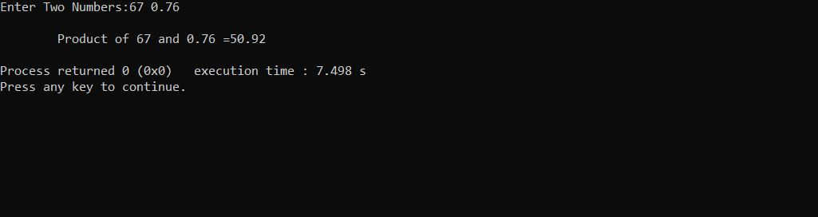

1. Give the function header for each of the following functions.
2. Function hypotenuse that takes two double-precision floating-point arguments, side1 and side2, and returns a double-precision floating-point result.

Double hypotenuse(double side1,double side2)

1. Function smallest that takes three integers, x, y, z, and returns an integer.

Int smallest(int x,inty,int z);

1. Function instructions that does not receive any arguments and does not return a value. [Note: Such functions are commonly used to display instructions to a user.]

void instructions();

1. Function intToFloat that takes an integer argument, number, and returns a floatingpoint result.

Float intToFloat(int number);